

About Member/International Affiliate Login Account

How to acquire Member/International Affiliate Login ID and Password 2

How to activate Member/International Affiliate Login Account 5

How to change Member/International Affiliate Login ID and Password 6

# How to acquire Member/International Affiliate Login ID and Password

Go to the HKICPA website at <http://www.hkicpa.org.hk>

**Step 1:**

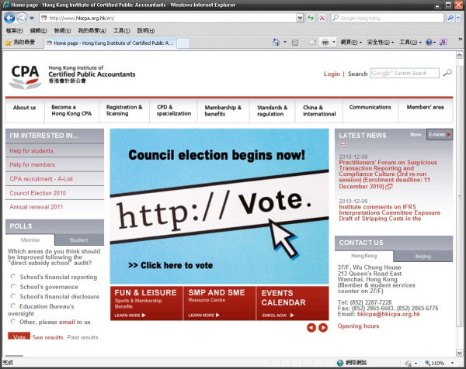

Click "**Login**"

**Step 2:**

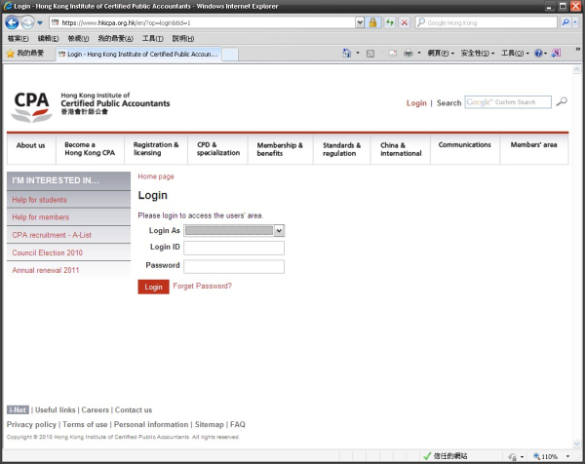

Click "**Forget Password?**"

**Step 3:**

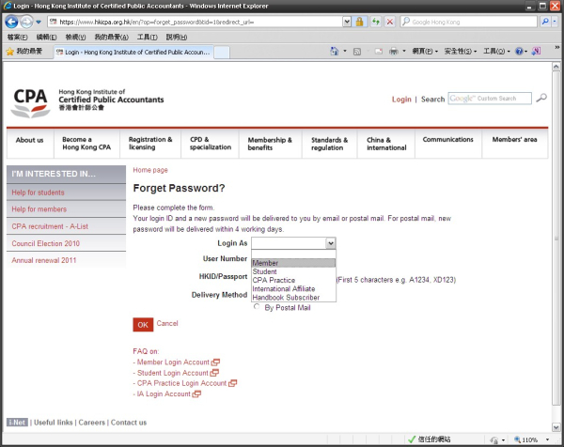

For CPA Members:

Choose "**Member**"

For International Affiliate:

Choose "**International Affiliate**"

**Step 4**

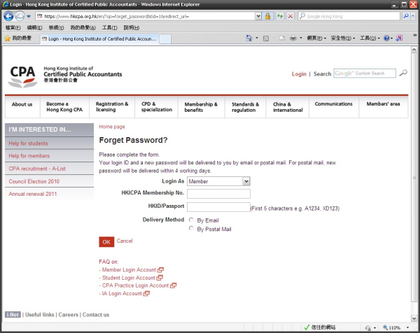

**Please enter:**

1. Your HKICPA Membership Number (e.g. A98765, F09876)

2. Your first 5 characters of your HKID or passport number (e.g. A1234, AA123)

You may choose to deliver a login ID and a new password to you by **email** or **postal mail**.

***For postal mail, new password will be delivered within 4 working days.***

Finally, click "**OK**"

**Step 5**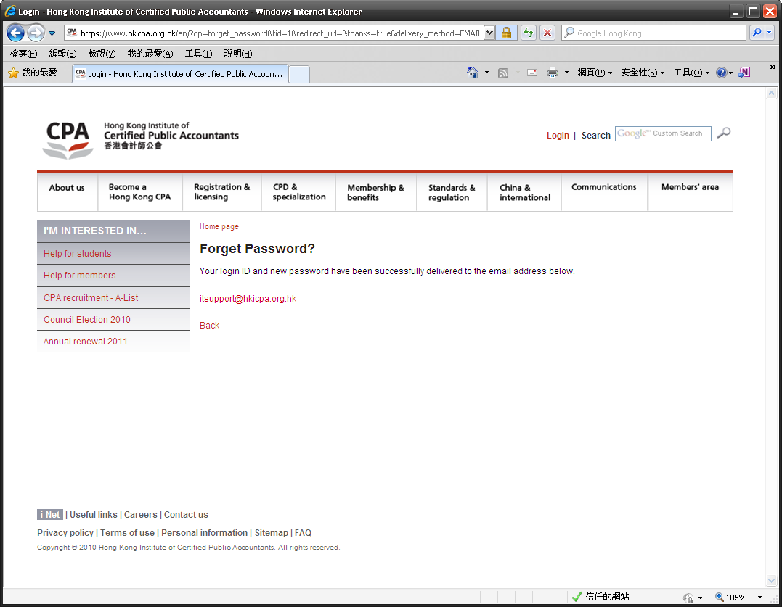

**If Member/International Affiliate has a registered email address**, corresponding Login ID and Password will be sent to members' registered email address automatically.

**If Member/International Affiliate has no registered email address**, corresponding Login ID and Password will be sent to member' registered correspondence address by mail. It takes approximately 4 working days to process.

For those members who already have approved Login ID or pre-assigned Login ID, but have not yet activated their login account. Only Login ID will be sent to students.

For detail instructions, please refer to the section below: "**How to activate Member/International Affiliate Login Account**"

Member can also change their Login ID through "**Change Login ID / Password**" under the Members' area. For detail instructions, please refer to the section below: "**How to change Member/International Affiliate Login ID and Password**".

# How to activate Member/International Affiliate Login Account

To access '**Member Login Account Activation Screen**', click the link below:   
<http://www.hkicpa.org.hk/en/login-account-activation/member/>

**Step 1:**

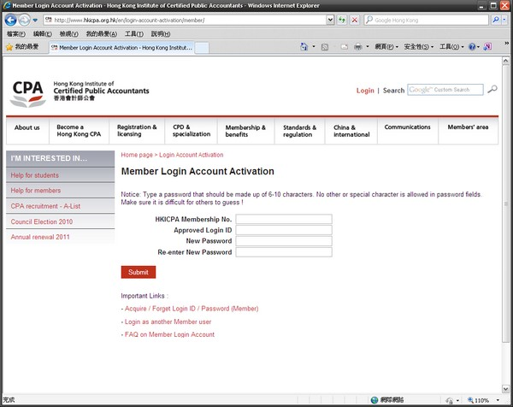

Finally, click "Submit"

**Please:**

1. Enter your HKICPA Membership number

2. Enter your Approved Login ID (Email or post sent to you already.)

3. Decide your new password and type it twice

# How to change Member/International Affiliate Login ID and Password

Go to the HKICPA website at <http://www.hkicpa.org.hk>

**Step 1:**



Click "**Login**"

**Step 2:**



For CPA Members:

Choose "**Member**"

For International Affiliate:

Choose "**International Affiliate**"

Finally, click "**Login"**

Enter your "**Login ID**" and "**Password**"

**Step 2:**

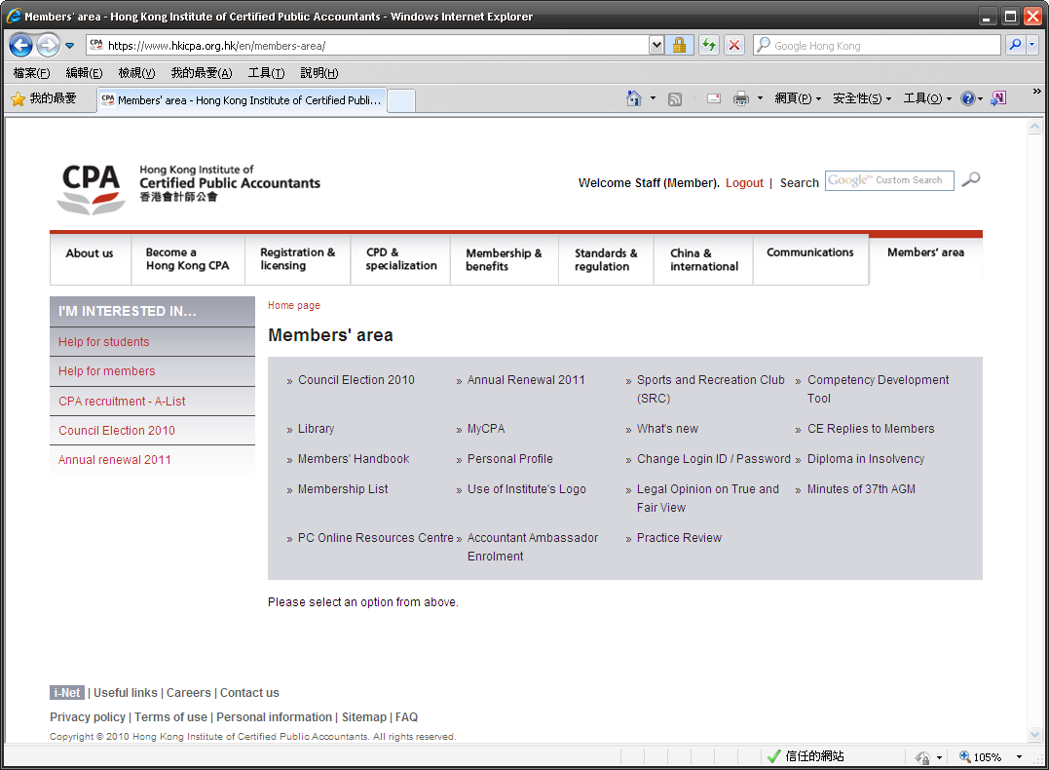

Click "**Change Login ID/Password**"

**Step 4:**

You can change either your **Login ID** or your **Password** independently or change both Login ID and Password at the same time. Simply fill out the boxes.

You must enter your old password to process your request and click "**Submit**" button to confirm your request.

***Attention:*** *Type Login ID that should be made up of 6-15 characters and Password should be made up of 6-10 characters. It may contain numbers (0-9), uppercase or lowercase letters (A-Z, a-z), underscore ( _ ) only. No other special character is allowed in Login ID and Password fields. Make sure it is difficult for others to guess!*

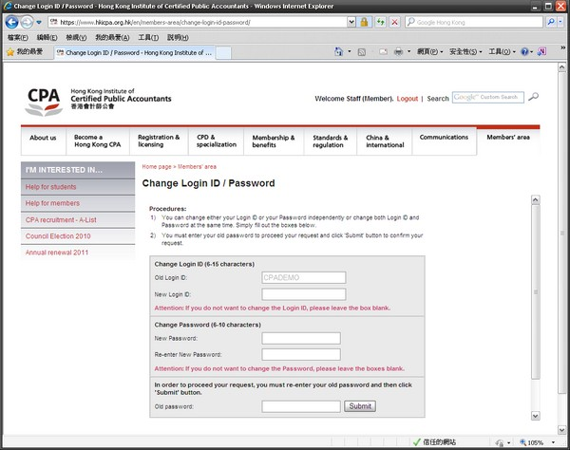

To change a **new** **Login ID**, enter in there, if not, leave it blank

To change **new password**, enter in there and type it twice, if not, leave it blank

Enter your old password to proceed.

Finally, click "**Submit**"