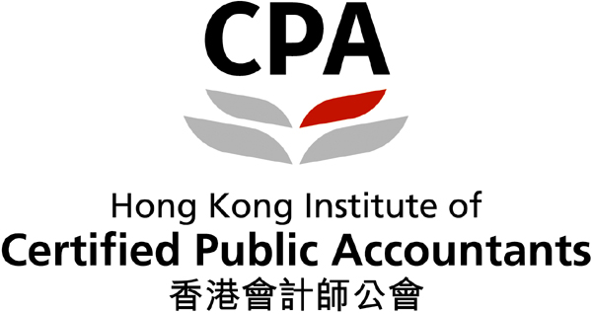

The HKICPA Accounting and

Business Management

Case Competition

2022-23

Secondary School Group

(Level 1)

Case Background

Kerry Logistics Network Limited (KLN), together with its subsidiaries (hereinafter referred to as the “Group”) operates as a leading logistics service provider in Asia. Its principal activities are (i) integrated logistics (IL) services, including storage and value-added services, trucking and distribution, returns management, and various ancillary services, primarily in Asia; and (ii) international freight forwarding (IFF) services intra-Asia and between Asia and Europe to transport cargo using air freight, ocean freight, and cross-border road freight forwarding services. With a global presence across 59 countries and territories, KLN is the largest international logistics company listed on the Main Board of The Stock Exchange of Hong Kong Limited (Stock Code 0636.HK).
The COVID-19 pandemic has severely affected the global supply chain owing to the mismatch between supply and demand, freight capacity chokeholds, port congestions, labour shortages, the shutdown of borders, and lockdowns. Specifically, KLN’s IL business shrank in 2021, mainly due to a weak Asian market with manufacturing and consumption-related activities disrupted by many prolonged lockdowns and other pandemic measures. For example, Hong Kong’s implementation of pandemic-induced social distancing measures caused a depression in particular retail activities and led to a contraction in the Group’s IL business.
On the other hand, the Group’s IFF business extraordinarily expanded with customers relying on the Group’s in-depth industry know-how, its extensive connections to ground operations, and its global network, especially for exports from Asia to North America and Europe. The Group has experienced more urgent fulfilment orders and ever more complex demand to overcome the multifaceted hurdles in the supply chain.
For the year ended 31 December 2021, the Group recorded a revenue of HK$78,954.7 million from continuing operations, representing a 59.1% increase from the year ended 31 December 2020 (2020: HK$49,617.2 million, restated). The Group’s profit from continuing operations increased by 182.9%, from HK$1,507.8 million in 2020 to HK$4,265.1 million in 2021.
The Group entered a strategic partnership with S.F. Holding in late 2021 to further enhance its overall competitiveness and become S.F. Holding’s platform for international business and international freight forwarding agent for international express services. Such a strategic partnership will give KLN an unparalleled advantage as Asia’s largest 3PL (third party logistics) provider to tackle the uncertain market challenges ahead.

REQUIRED
Assume that you are newly employed by Kerry Logistics Network Limited (KLN) as a financial analyst. Your supervisor asks you to prepare a report to analyze the Group’s financial and business environment. Your report should include the following sections:

- A concise overview of (i) KLN Group’s current business and (ii) the logistics industry’s challenges during the COVID-19 pandemic. (5 marks)

- A tabular analysis of KLN Group’s financial ratios with appropriate interpretation.
- Use KLN Group’s 2021 Annual Report to prepare your answers. The financial statements for 2020 have been restated and shown on the 2021 Annual Report.
- For all ratios:
- Refer to the “continuing operations” of the Consolidated Income Statement.
- Apply “Year-end” (i.e., 31 December) figures on the Consolidated Statement of Financial Position.
- Show calculation workings and keep two decimal places.

 | Formula |  | Ratios |  | 2021 Annual Report Ref. page
 |  |  | 2021 | 2020
Profitability Ratios
Mark up | Gross Profit / Direct Operating Expenses | x 100% | % | % | p. 96
Gross Profit Margin | Gross Profit / Revenue | x 100% | % | % | p. 96
Net Profit Margin | Profit Before Taxation / Revenue | x 100% | % | % | p. 96
Comments
Management Efficiency Ratios
Total Assets Turnover | Revenue / Total Assets |  | times | times | p. 96, p. 98
Comments
Liquidity Ratios
Current Ratio | Current Assets / Current Liabilities |  | :1 | :1 | p. 98
Cash Ratio | Cash and Bank Balances / Current Liabilities |  | :1 | :1 | p. 98
Comments
Solvency Ratios
Debt to Equity Ratio | Total Liabilities / Total Equity | x 100% | % | % | p.98, p. 99
Gearing Ratio | Non-current Liabilities  Non-current Liabilities + Total Equity | x 100% | % | % | p. 99
Comments
Return on Investment Ratios
Earnings Per Share (EPS) | Profit for the Year from Continuing Operations  - attributable to the Company’s shareholders  Weighted-average No. of Ordinary Shares |  | $ /share | $ /share | p. 96,  p. 145
Dividend Cover | Profit for the Year from Continuing Operations  - attributable to the Company’s shareholders  Total Dividends |  | times | times | p. 96,  p. 145
Comments
(65 marks)
- A business analysis for each of the following three areas with reference to KLN Group’s:
  - 2021 Annual Report; and
  - 2021 Sustainability Report.

Identify at least four examples of achievements and make one suggestion for improvement.

Environmental Protection | Achievements:
 | Improvement:
Corporate Social Responsibility | Achievements:
 | Improvement:
Corporate Governance | Achievements:
 | Improvement:
(30 marks)
(Total: 100 marks)

Notes
- In preparing your analysis, you should refer to KLN’s website for
- 2021 Annual Report at https://www.kln.com/en/investors/financial-reports-presentations/, and

- 2021 Sustainability Report at https://www.kln.com/en/group/sustainability/sustainability-report/.

- You are required to carry out a tabular financial analysis for the past TWO years, for the years ended 31 December 2020 and 2021.
- All calculations should be supported by appropriate formulas and workings.
- Keep two decimal places in your answers.

- Make clear references to all materials used in the analysis.

Useful reference
- HKICPA Accounting and Business Management Case Competition Website
https://www.hkicpa.org.hk/amcc

- Kerry Logistics Network Limited website
https://www.kln.com/en/

REPORT FORMAT AND RULES
1. Each participating student or team should submit a report in English or Chinese. The language used depends on the choice indicated on the registration form. The report should contain the following:

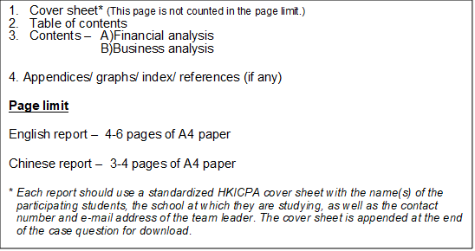

2. Font type and size: English report – Arial (12 points). / Chinese report –新細明體
(11 points). 1.5 line spacing. Margin: 1 inch for each side.

3. The content pages SHOULD NOT include the names of team members and the school at which they are studying.

4. Submit the following items in SOFT COPY (PDF format):
● An analysis report; and
● An HKICPA cover sheet.

5. Save the analysis report and cover sheet in TWO separate PDF files with respective file names being shown as:
• "Team leader full name_Team leader mobile phone no._Analysis Report"
(e.g. Chan Tai Man_98765432_ Analysis Report)
• "Team leader full name_Team leader mobile phone no._Cover Sheet"
(e.g. Chan Tai Man_98765432_Cover Sheet)

6. Send the TWO PDF files in one email to amcc@hkicpa.org.hk, with email subject named as "Level 1_Team leader full name” (e.g. Level 1_Chan Tai Man). Multiple submissions will be disqualified.

7. The deadline for submission: Before 23:59, 14 February 2023 (the email receiving time by the HKICPA's mailbox shall prevail).

8. The HKICPA has the right to disqualify any participant or team if the participant or team is found to have violated the rules of the competition.

9. Please scan the QR code on the right to complete an online questionnaire for the competition.

The HKICPA Accounting and Business Management Case Competition 2022-23
(Level 1)
Cover Sheet
Please attach this cover sheet to your analysis report
(Please complete in BLOCK LETTERS)
School name
Format | Team / Individual # | (#please delete as appropriate)
Participant(s) information:
*Please use BLOCK LETTER to fill in below information. The names provided below should be identical to the name of participants’ identity card, which will be used for printing certificate.
Name of Team leader/
Individual participant
Email address
Contact number
Team members (if any)
Name of Team Member 1
Name of Team Member 2
Name of Team Member 3
Name of Team Member 4

Document checklist:
Email this cover sheet An analysis report in PDF format
^Any missing documents or incomplete analysis may result in the disqualification of your participation.
For official use:
Report received on
Assigned Team no.
Total marks
Handled by

